Starting the Garda Vetting Process online via GAA website
There are 2 steps in completing a Garda vetting form online.
- First a user must submit the request for a vetting application through the GAA website. This includes details of a contact email address.
- The user is then sent back a link by email which they must click on to complete the actual Garda Vetting form itself.
The link to starting the GAA process for completing a Garda Vetting Application online is as follows:
http://gaa.flowforma.com/Lists/Forms/NewForm.aspx?FlowId=1
Step by Step
However users can also follow the steps below to access it within the GAA website
First go to http://www.gaa.ie/ in any Internet browser
Click on the Button called THE GAA on the Top right of the screen
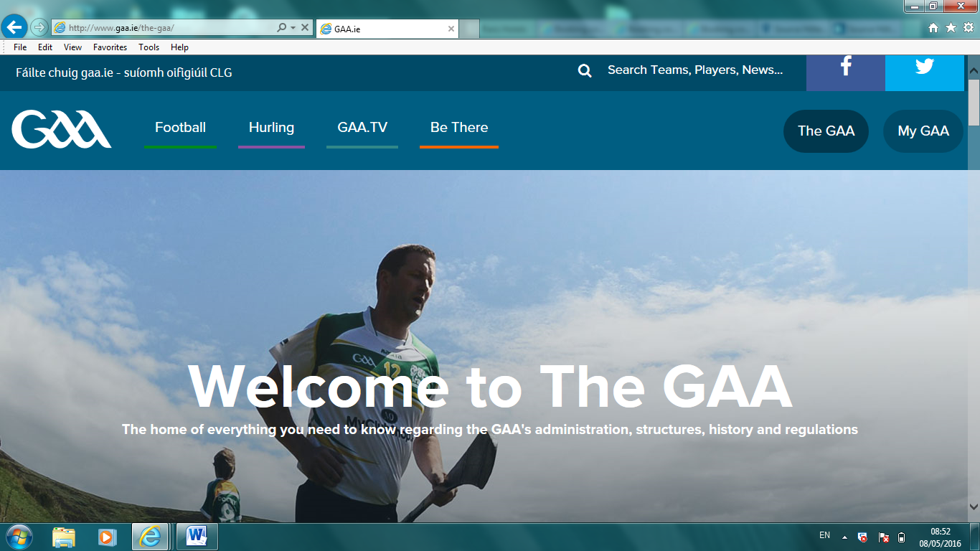
Move/Scroll down to the bottom of this page until you find the link for Child Welfare and Protection
Click here to enter the Child Welfare section
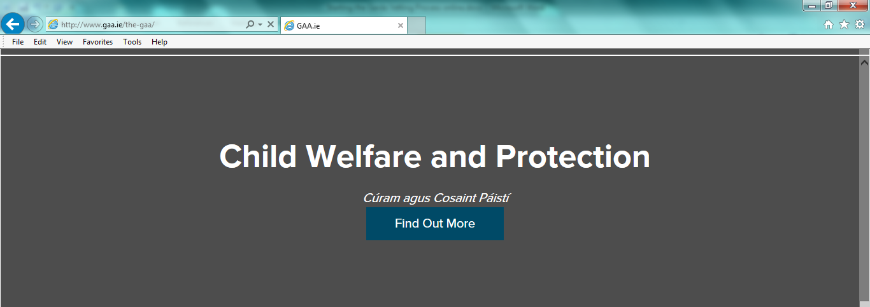
Then select the Vetting button from the list of options

A small sub-menu will appear with 2 options- Select E Vetting Application
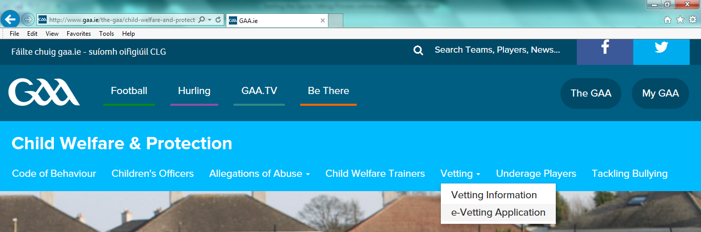
This will bring you to
http://gaa.flowforma.com/Lists/Forms/NewForm.aspx?FlowId=1
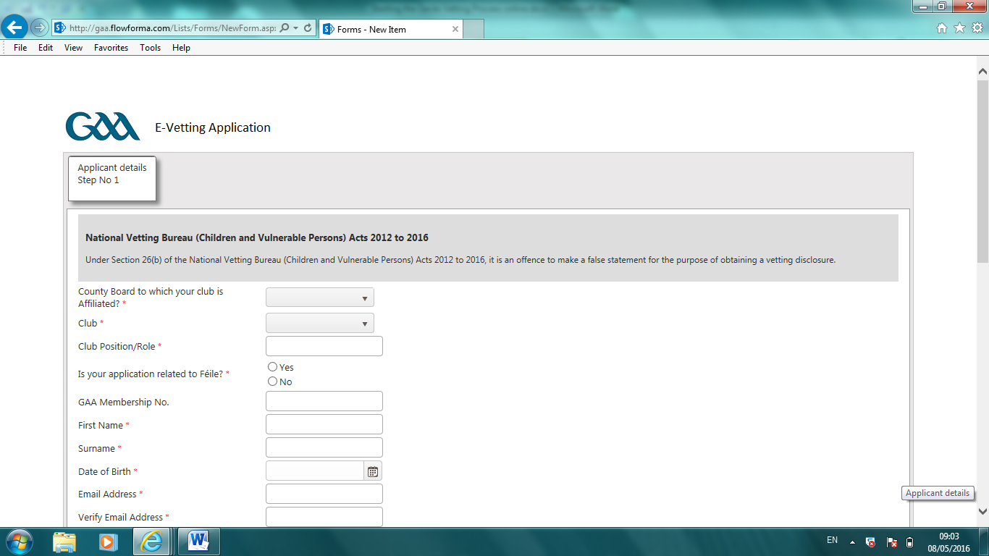
Then complete the application online and click the Submit button at the bottom
This will verify that all the required information has been completed and will return a reference number.
Remember that this is only the first step and that you have not submitted any information to the Gardai at this stage- only an online request to apply to be vetted.
